
TRARALGON TENNIS ASSOCIATION WARMLY INVITES

To our EVENING WITH THE STARS DINNER
during the AGL Loy Yang Traralgon International, proudly sponsored by



Saturday January 18, 2020
Traralgon Tennis Association

Please join us on the decking anytime from 5.30 pm to watch the tennis
Guests to make their way into the function room from 6.30 pm with a two-course buffet dinner to follow at 7pm

The evening will provide an opportunity for Corporate Sponsors, Members and Guests to gather.

SPECIAL GUEST – MR CHRIS ANSTEY
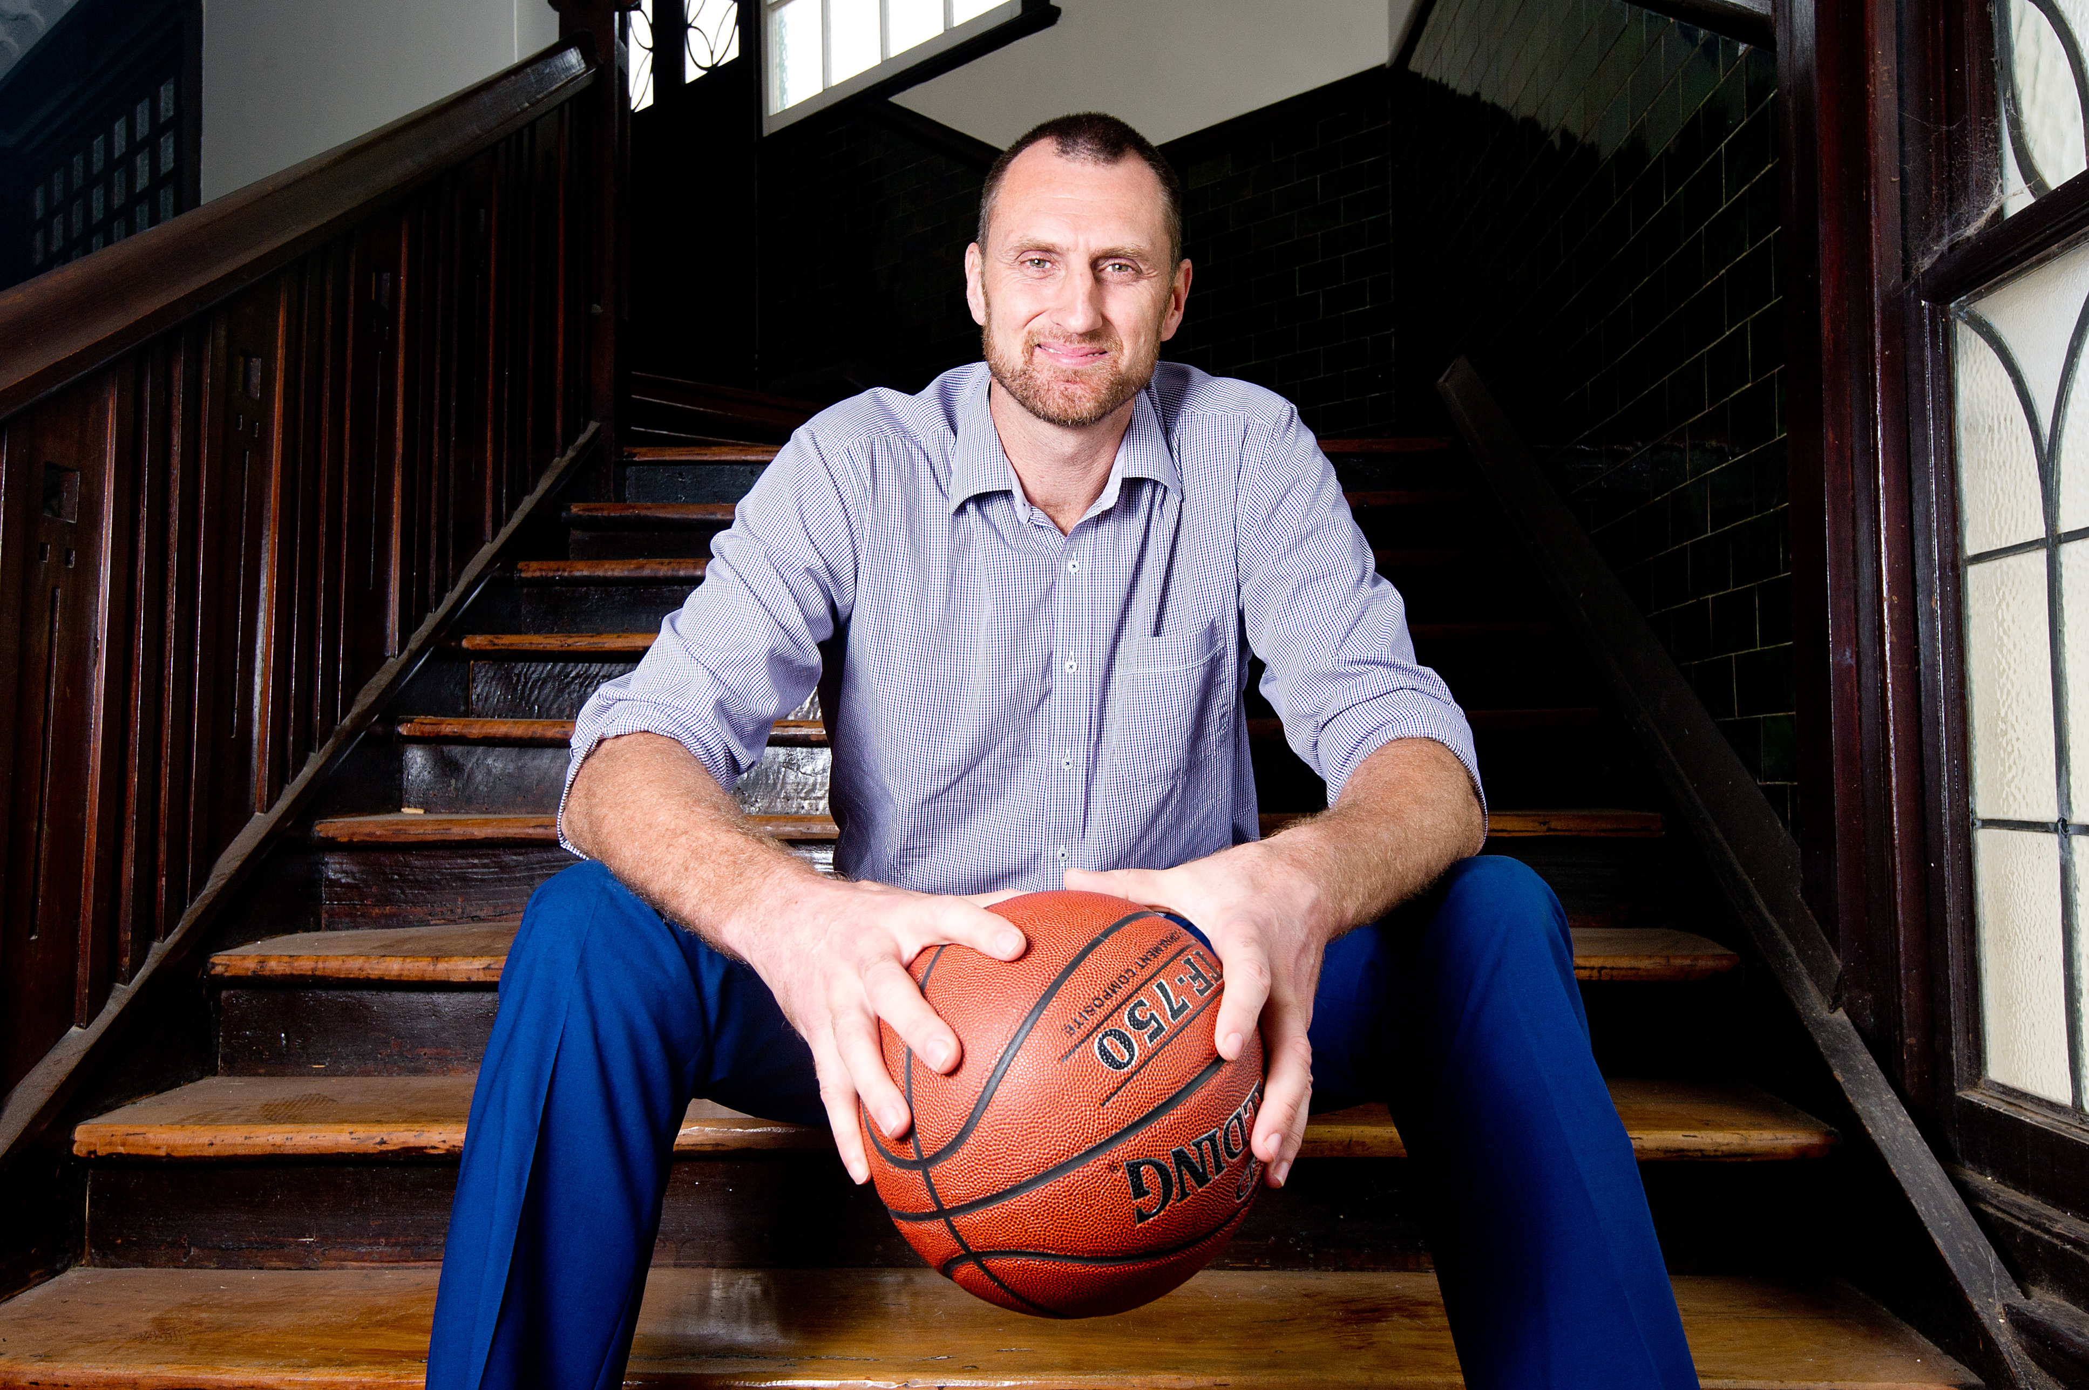
We welcome Chris Anstey, Australian former professional basketball player with the NBA, Melbourne Tigers, South East Melbourne Magic and Victoria Titans. Chris is a three-time NBL Champion and two time Olympian. Chris was an accomplished tennis player prior to commencing his basketball career, growing up playing with Mark Phillippousis and Essendon Football Club great Dustin Fletcher. Chris has recently spent 18 months working with WTA World ranked Coco Vandeweghe and her coach Craig Kardon.

SEMI FORMAL DRESS $70.00 per ticket
Individual tickets or tables available
RSVP Susie Grumley 0419 383 707
Monday January 13, 2020
(Please forward any special dietary requirements with your RSVP)

MC Mr Brenton Wight
Music throughout the evening by Justin Rebbechi




Lucky Ticket Winner will receive a double pass to a session of the
Australian Open on Saturday January 25, 2020

Complimentary beer, wine, champagne and soft drink on arrival, other drinks at bar prices

