**YOUR CHANCE TO GET CLOSE TO THE ACTION!**

**COULD THIS BE YOU STANDING BESIDE ONE OF TENNIS’ BEST**

***Come and play a part in this great event!***

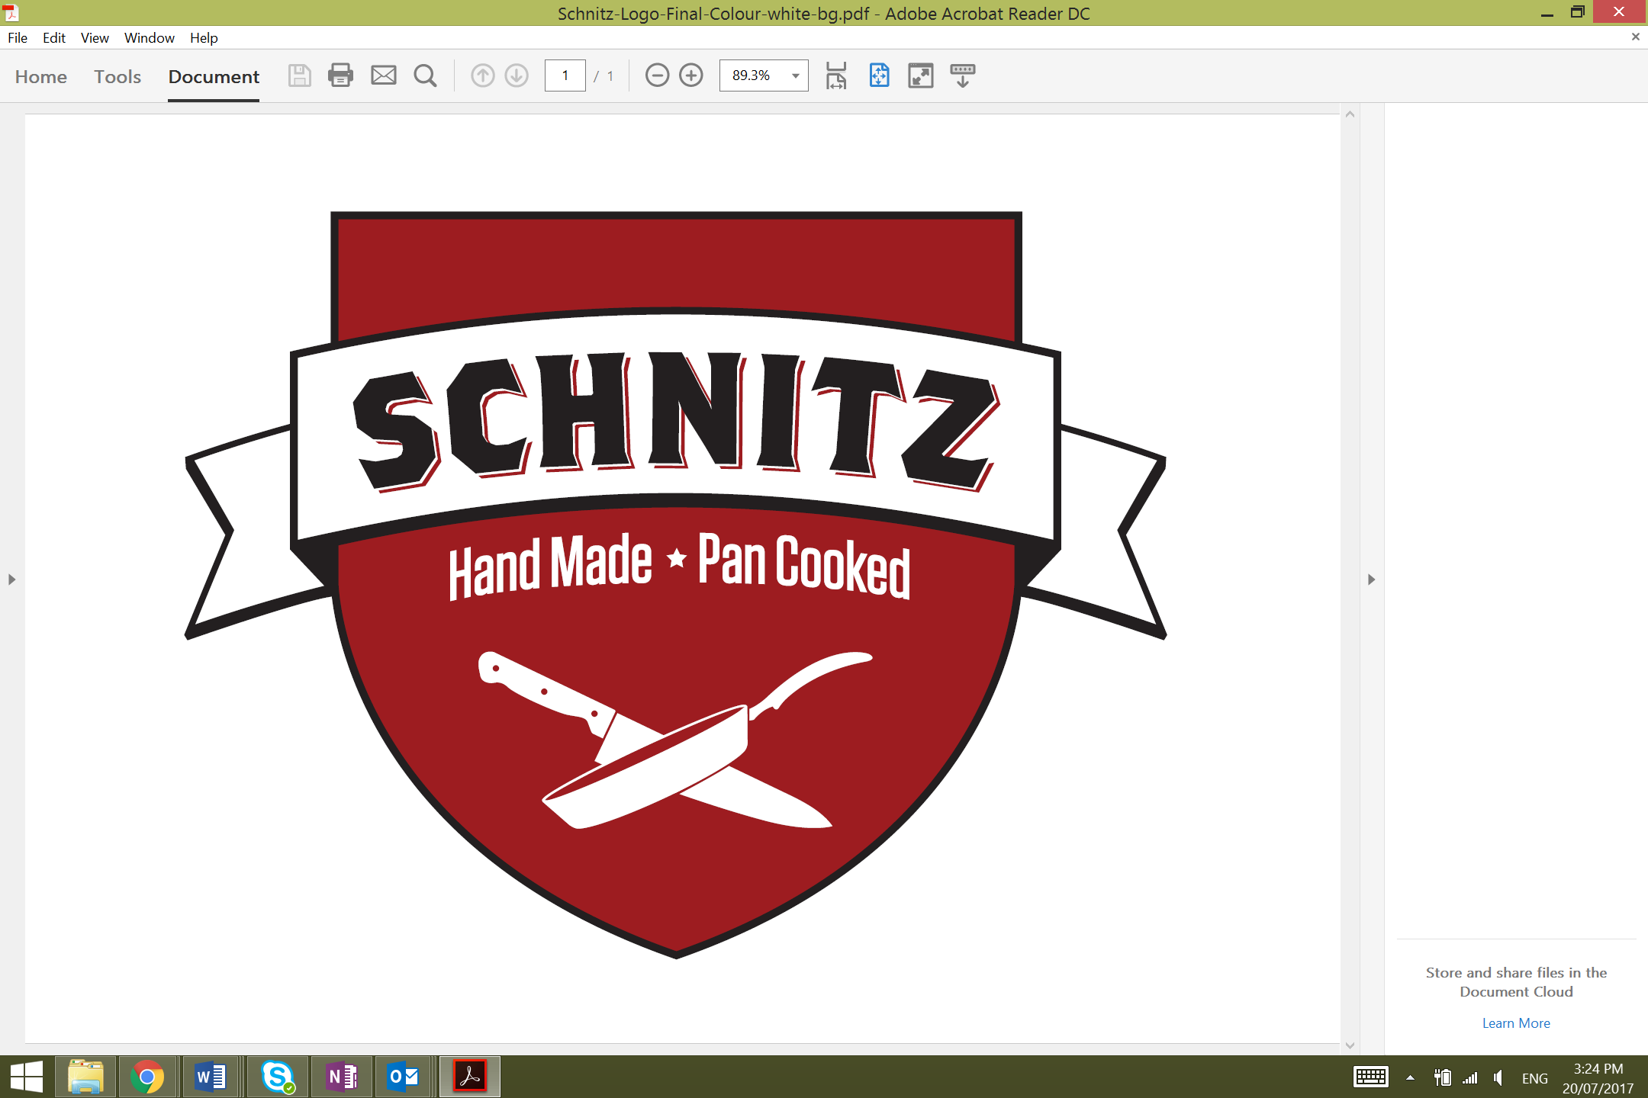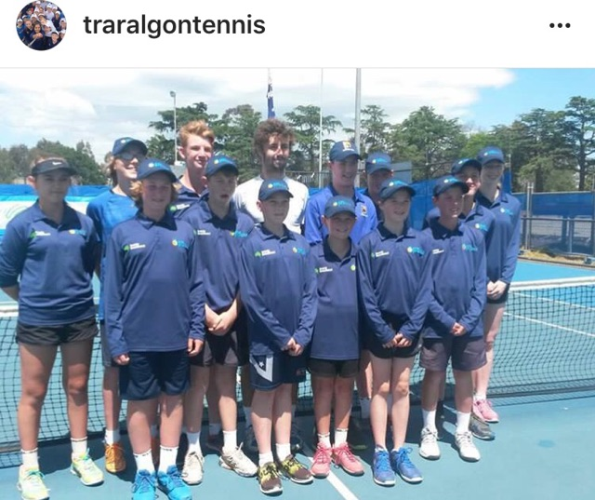

2016 Ball Kids with winner and World No. 80 Jordan Thompson

**Latrobe City Traralgon ATP Challenger**

The Traralgon Tennis Association is calling for Ball Kids for this year’s Challenger Event from Saturday 21 October through to Sunday 29 October 2017. All participants will be provided with a ball kid t-shirt, hat, drink bottle and lunch daily. Ball kid shifts start from 9am. Official ball kid training will be held prior to the event.

To register your interest or for more information please contact Susie Grumley, 0448 551 610 or [sec@traralgontennis.com](mailto:sec@traralgontennis.com)

